SpendWise: A Simple Backend Learning Project
Ideation Phase
Brainstorm & Idea Prioritization

Date | 15/03/2026
Team ID | SWTID-2026-9830
Project Name | SpendWise
Maximum Marks | 4 Marks

Brainstorm & Idea Prioritization Template:
Brainstorming creates an open environment where team members can freely share ideas to solve a problem. For SpendWise, the goal is to generate simple, practical ideas that help students learn backend development. All ideas are first listed without judging, then grouped, and finally prioritized based on usefulness and feasibility for beginners.

Step-1: Team Gathering, Collaboration and Select the Problem Statement
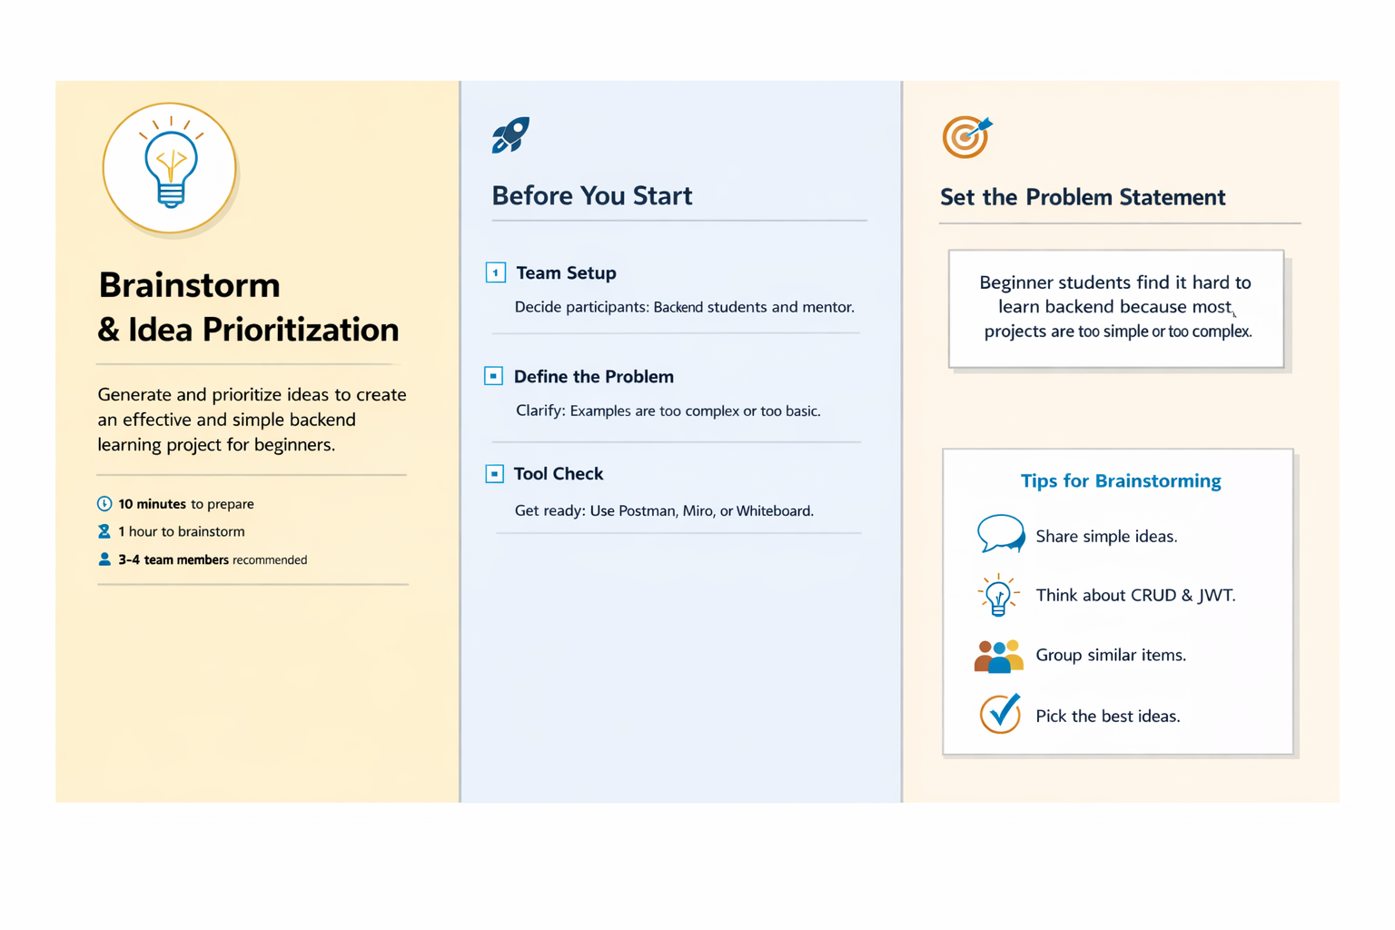

Step-2: Brainstorm, Idea Listing and Grouping
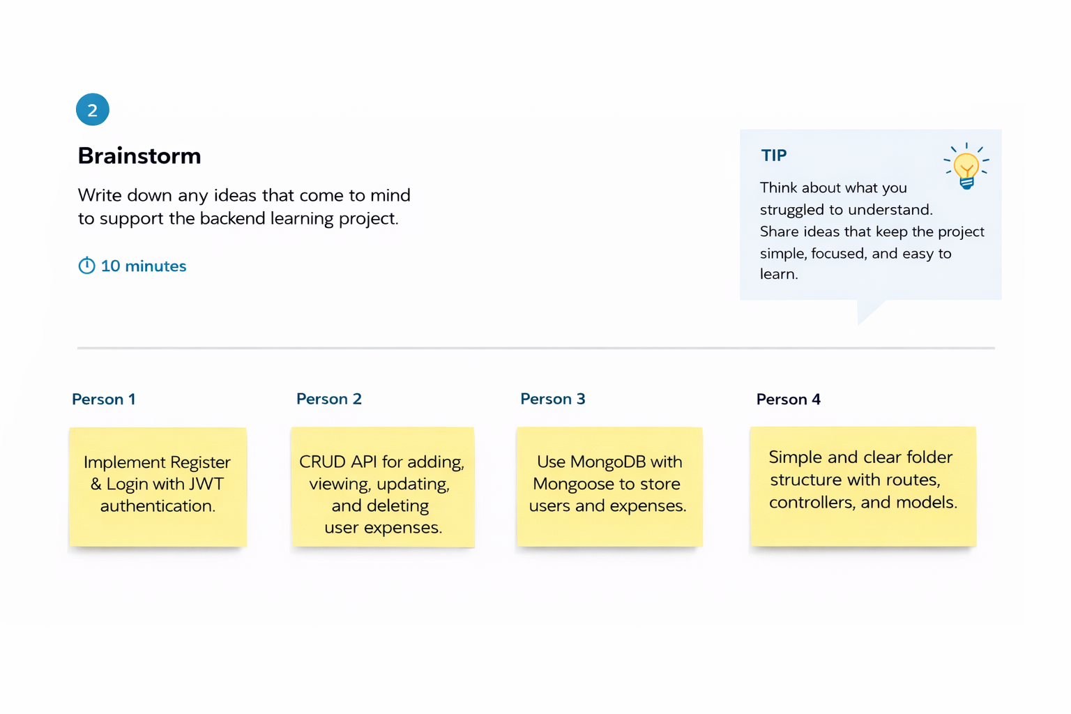
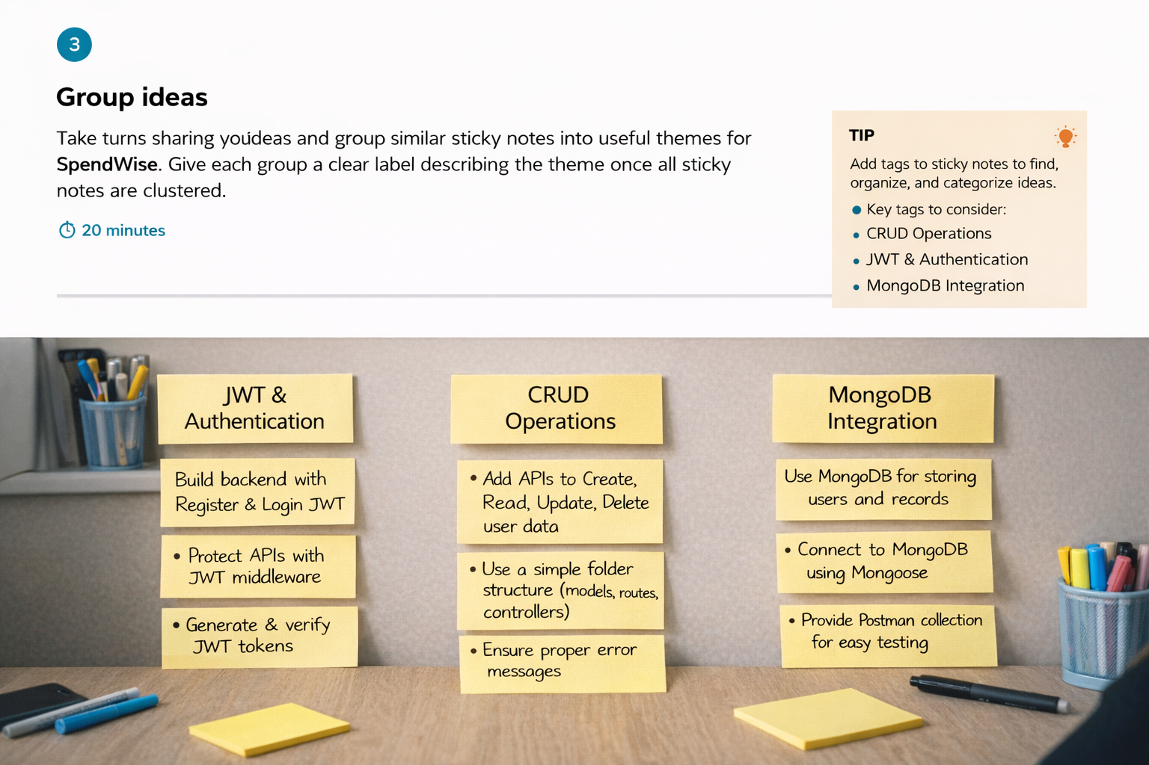

Step-3: Idea Prioritization
